GTB  
  
**QA**  
[DEV 20.38] OT-948 | XT | DE | AS | 3.0 Popin - NGC BP-A – 09 Oct 2020

**Jira ticket:**  
<https://jira.uhub.biz/browse/GTBEMEAOPT-948>

**Site**  
<https://www.ford.de/>

**Test location**  
Across ford.de - apart from E-comm configurator, E-comm Pre-order Journey, 1.0 Configurator and TDR, any page related to Owners / Services

**Test Description**

There are 2 parts to this ticket:

1. Collecting the Data
2. Displaying the popup

It has to happen in that order.

NOTE: This ticket only works for vehicles using the new Build and Price configuration (see image below), no data will be recorded if the old configurator is used.

**Collecting the Data:** View the QA Link, in the top right corner select “Konfigurator”. At the time of writing no “nutzfahrzeuge” vehicles are using the new build and price configurator and 2 vehicles from the “fahrzeuge” are on the old build and price, the “FORD TOURNEO COURIER” and the “FORD TOURNEO CUSTOM”. To configure a vehicle mouse over one of the vehicles and click the blue button that appears you should now be in the Build and Price section, you can also leave now to trigger a popup. Some popup locations will only appear if you selected a specific model though, so if that’s the idea, please select a model before leaving the page in order to get a popup to appear.

**New Build and Price Screen and the Model Selection screen (Image 1.1):**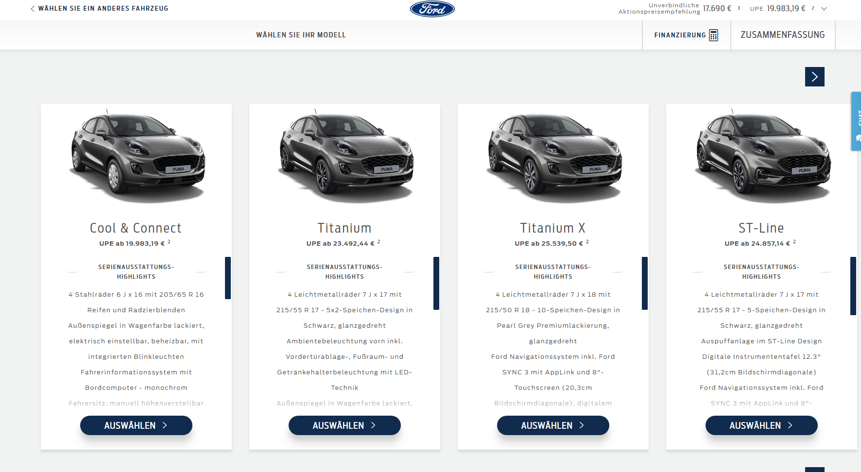

**Old Build and Price screen (Image 1.2):**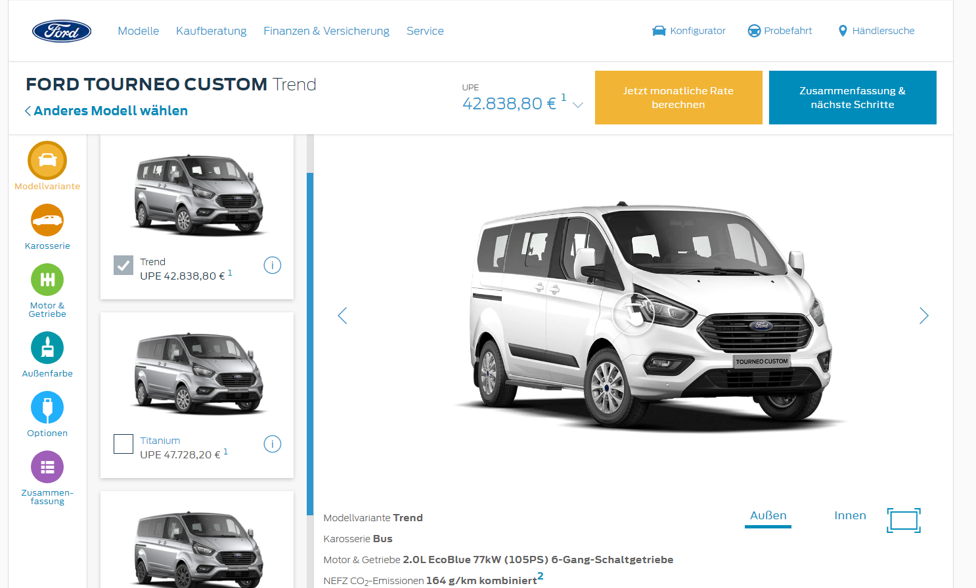

**Displaying the Popup:** The popup can display in multiple locations if certain conditions are met. The below will display the location, the url, where possible, which you can click on directly as well as the conditions required for the popup to appear. Also note that not all of the below can currently be triggered, as the vehicles required may not be available to build due to them either using the old system or not being available at all.

* Home Page
  + <https://www.ford.de/>
  + All vehicles can display here.
* Nameplate Pages
  + These can be found by mousing over “Modelle” and selecting one of the vehicles, this area is referred to the Mini Showroom.
  + It will only appear here if the vehicle built matches the nameplate page you’re viewing.
* SUV Page
  + <https://www.ford.de/fahrzeuge/suv-gelaendewagen>
  + If the vehicle is present in the SUV & Crossover Mini Showroom
* Hybrid and Electric Page
  + <https://www.ford.de/kaufberatung/informieren/hybrid-elektrofahrzeuge>
  + If the vehicle is present in the Hybrid & Elektrisch Mini Showroom
* Family Cars Page
  + <https://www.ford.de/fahrzeuge/familienautos>
  + If the vehicle is present in the Familienautos Mini Showroom
* Performance Page
  + <https://www.ford.de/fahrzeuge/performance-sportwagen>
  + If the vehicle is present in the Performance Mini Showroom
* Commercial Vehicles
  + <https://www.ford.de/nutzfahrzeuge/vorstellung>
  + If the vehicle is present in the Nutzfahrzeuge Mini Showroom
* ST-Line
  + <https://www.ford.de/fahrzeuge/ford-st-line>
  + If the vehicle is ST-Line
* Vignale
  + <https://www.ford.de/kaufberatung/informieren/ford-vignale-entdecken>
  + If the vehicle is Vignale
* Motorhome
  + <https://www.ford.de/fahrzeuge/freizeit-reisemobile>
  + If the vehicle is Transit Custom Nugget or Transit Custom Nugget Plus
* Small Vehicle
  + <https://www.ford.de/fahrzeuge/kleinwagen>
  + If the vehicle is Fiesta, Ecosport or Puma
* People Carrier
  + <https://www.ford.de/fahrzeuge/mpv-minivan-kleinbus>
  + If the vehicle is Tourneo Courier, Tourneo Connect, S-Max, Galaxy, Tourneo Custom or Transit Bus

The popup can only appear a maximum of 3 times, with a 15 minute duration in between popups. Popups appear after 15 seconds of landing on the page. The CTA on the popup will return the user to the point where he dropped off, or the next step based on whether a selection was required on the page you dropped off on.

For example, if you just entered the build and price and left. You’d return to that exact page as you need to make a choice between which model you want. Whereas if you were on the colour page, the colour is pre-selected once it loads so you would go to the next step which is Interior ( I think ).

So in short, if the page you’re on contains only 1 button for you to proceed to the next step, usually found in the bottom right corner, then leaving this page will take you to the next page, however if you’re on a page where there are multiple options similar to the Model Selection screen, you will return to this page.

**The Popup (Image 1.3):** 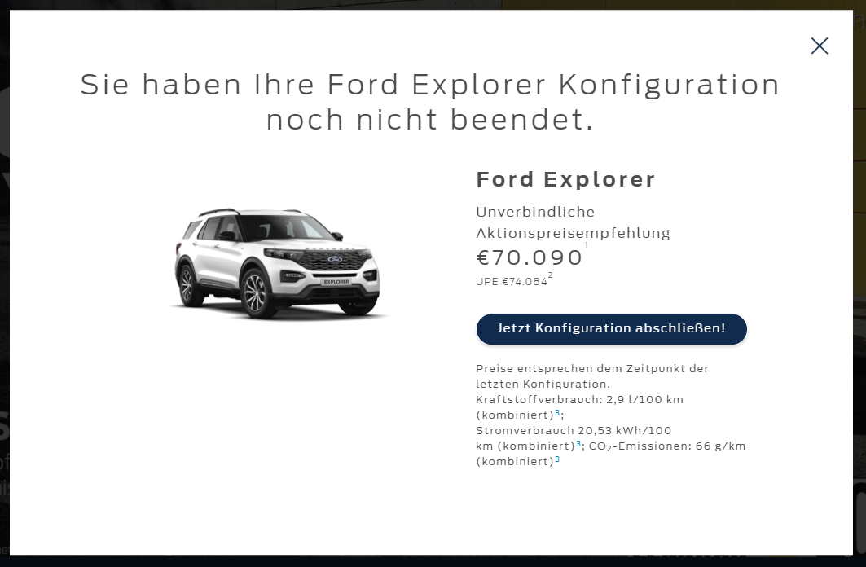

Not all vehicles will have 2 prices shown, for example if you look at Image 1.1, in the top right corner there’s 2 prices currently. So you can assume the popup will only have 1 price. Some vehicles might only have 1 popup.

**Browser:**   
All  
  
**Device:**   
All  
  
**Audience rules:**   
All traffic

**QA Link:**

<https://www.ford.de/?at_preview_token=NsyFRJ9iNHcTEFIvzF9GAw&at_preview_index=1_1&at_preview_listed_activities_only=true>